Import Workflow & Case Entity Solution

1. Navigate to Settings|Solutions & import Case_sublime_1_0_0_0.zip as shown below

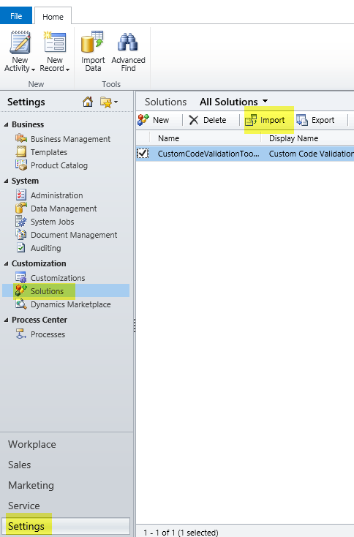

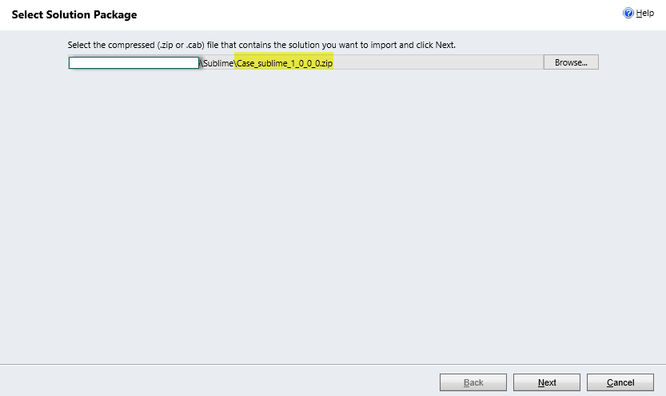

1. Check Activate any process…. 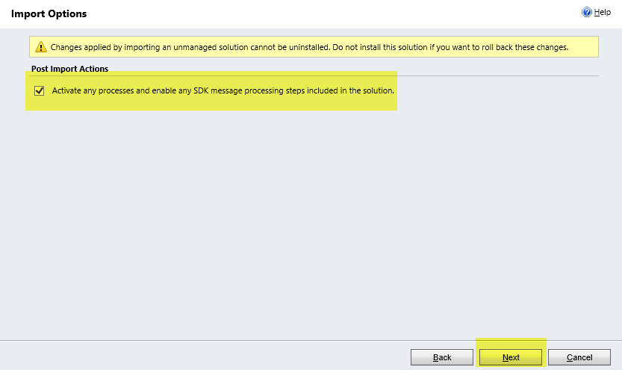
2. Click next and at the end publish all customizations.

Activate Case Child Workflow

1. Navigate to Settings | Processes and open Case Child Workflow as highlighted below:

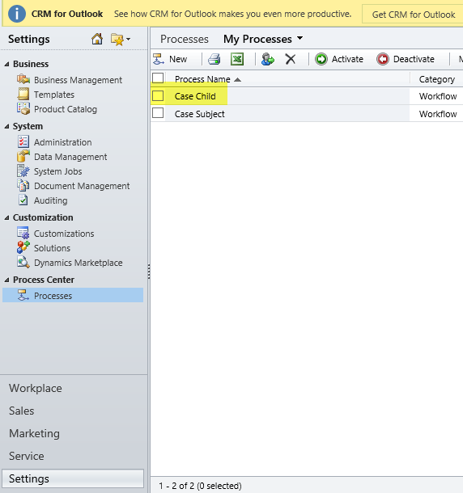

1. If you see the red cross as highlighted below it means workflow contains invalid references of Subject data. Follow the subsequent steps to get rid of this error.

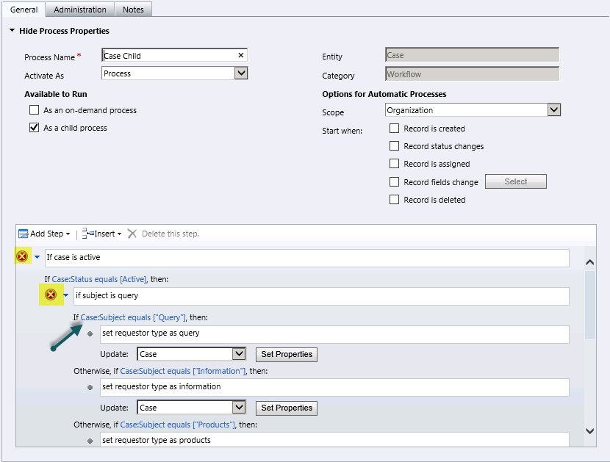

Click on the link pointed by the arrow in the above image .

1. A new popup will open as shown below. Click on the button to popup lookup value selection window

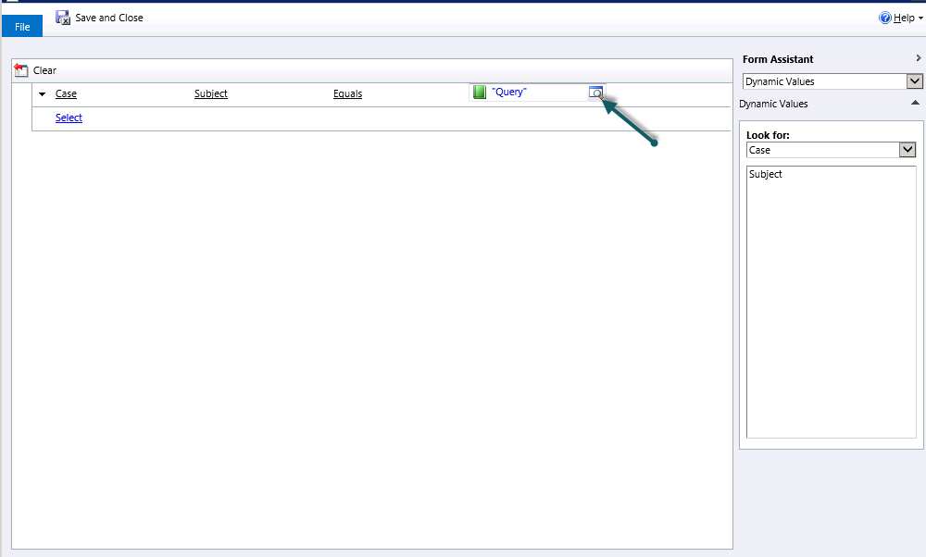

1. Set lookup value to Query instead of “Query”. Click ok

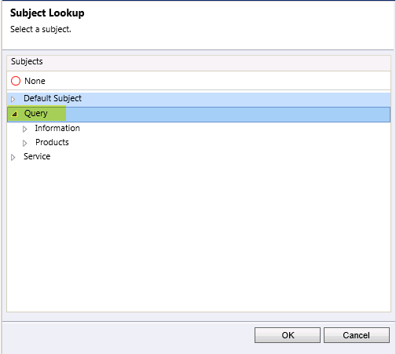

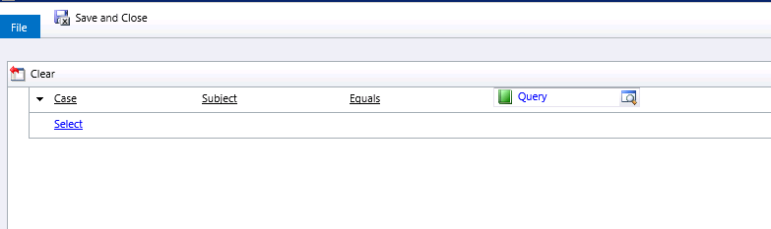

Notice that Query is now without quotes (“”)

1. Do this for remaining values (Information, Products, Delivery, Maintenance, Service, Default Subject)

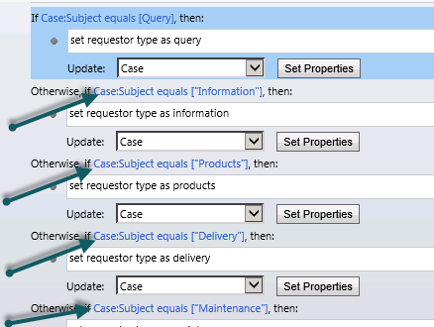

1. After setting all values the workflow should show all values without quotes as shown below

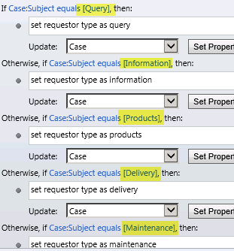

1. Save workflow and click on Activate button to activate the workflow.

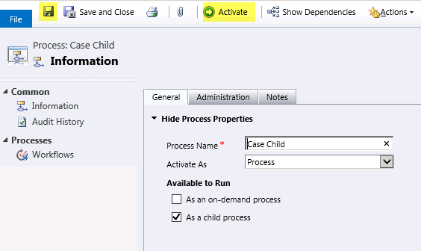

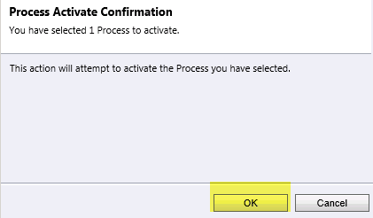

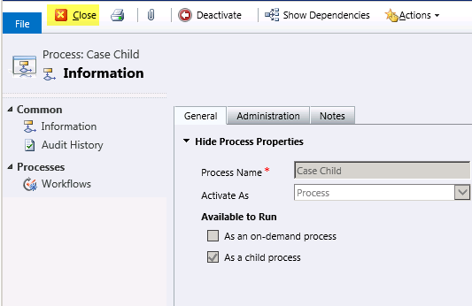

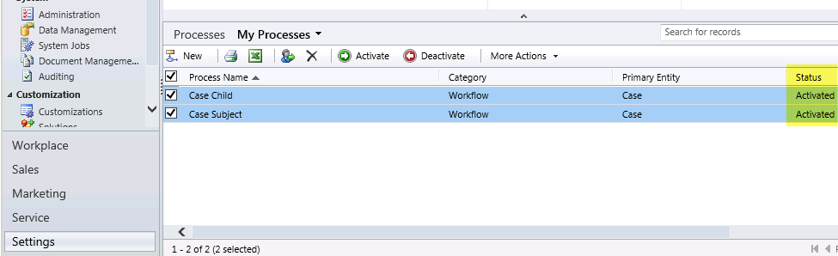

Update existing Case records

1. Navigate to case entity records in CRM
2. Select Workflow view from view drop down.

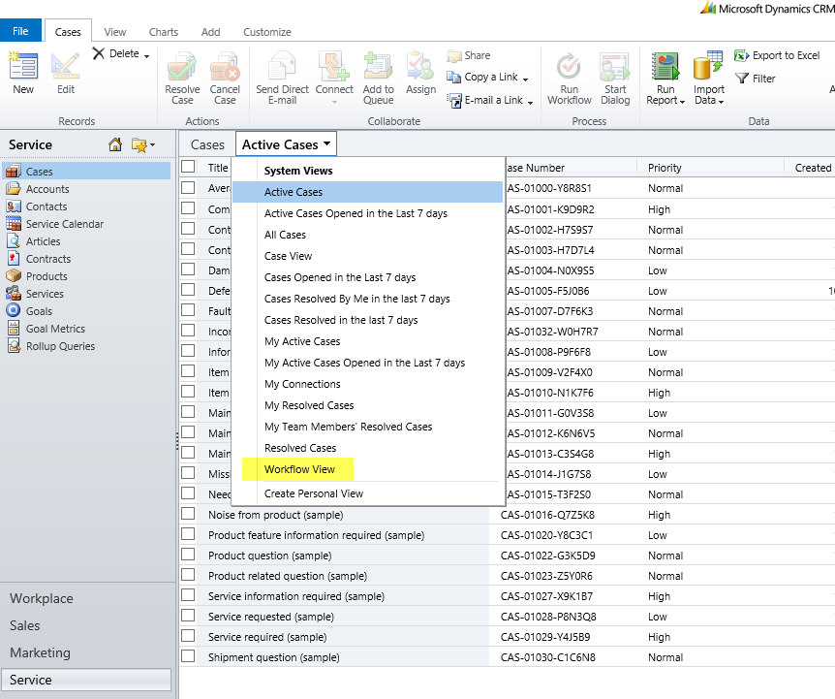

1. Select all case records in the view.

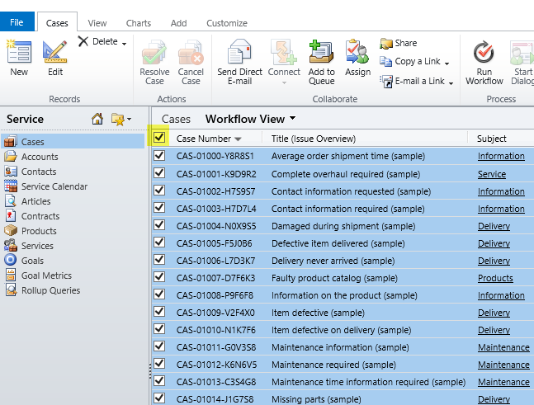

1. Click on Run Workflow button on the top.

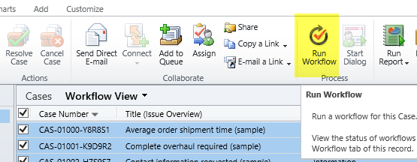

1. Select Case Subject & click ok.

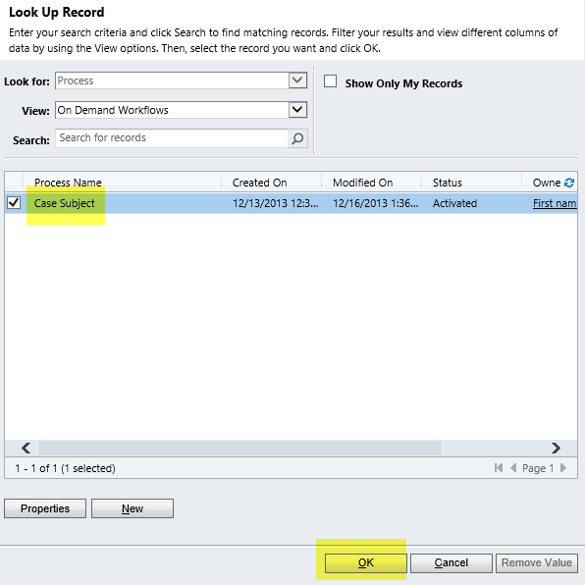

1. Confirm workflow execution by clicking ok.

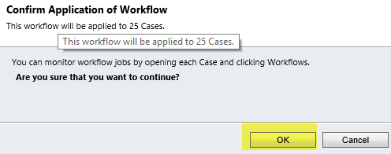

1. See the last two columns. Requestor type field value is same as corresponding Subject.

